ASSIGNMENT – 4

# Assignment -4

Python Programming

|  |  |
| --- | --- |
| Assignment | 4 |
| Student Name | ROSHNI B |
| Student Roll Number | 1919102126 |
| Maximum Marks | 2 Marks |

Write a code and connections in wokwi for ultrasonic sensor. Whenever distance is less than 100 cms "send" alert to IBM Cloud and display in device recent events.

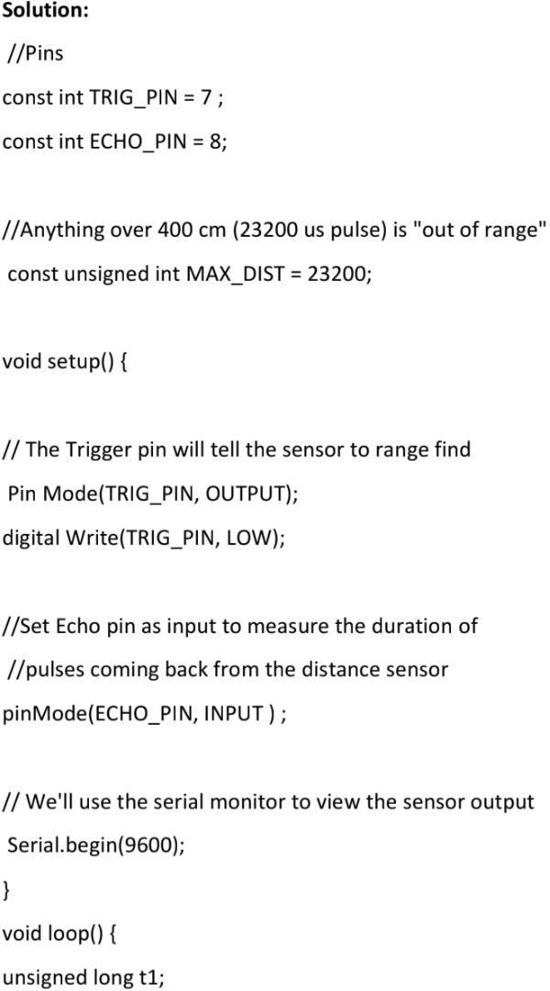

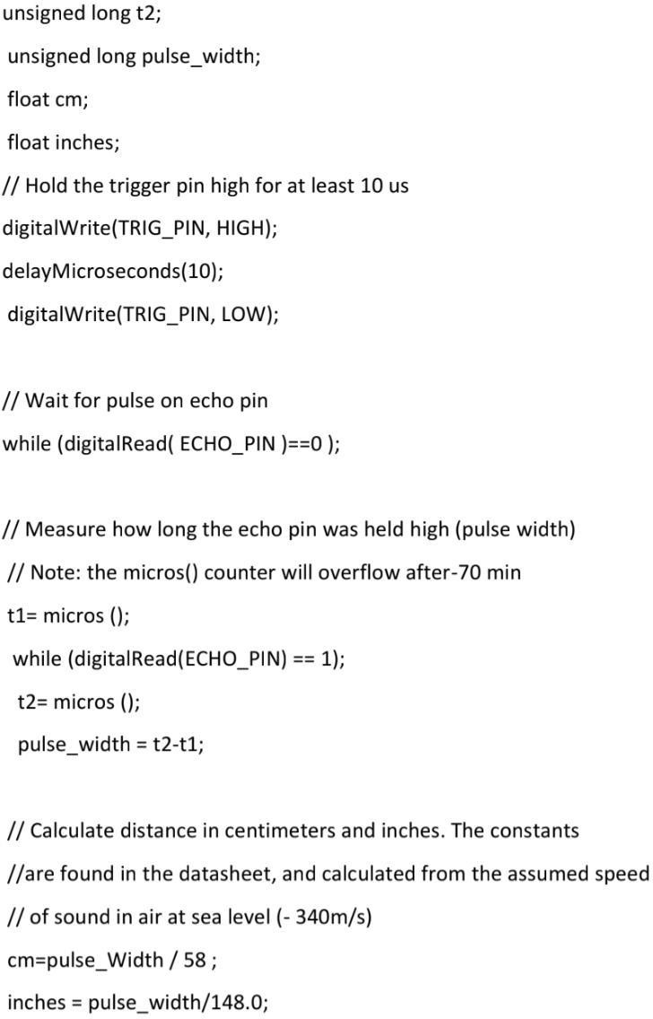

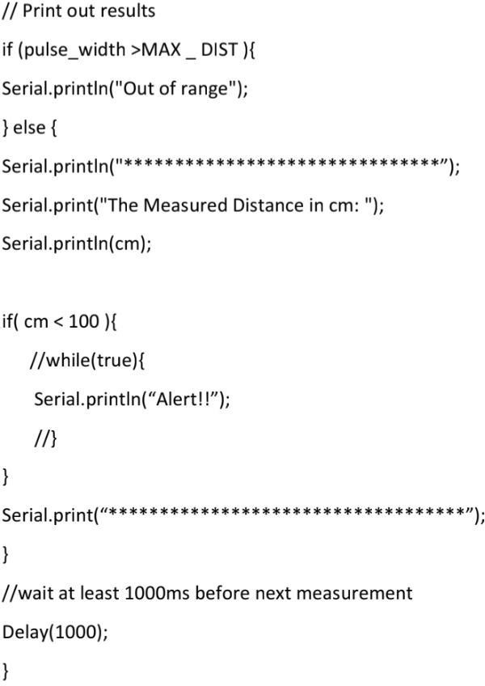

**OUTPUT:**



